SIMATS ENGINEERING
ASSESSMENT TOOL 3

COURSE NAME: Ethical Hacking COURSE CODE: ITA1435

COURSE OUTCOME COVERED

CO2: Execute footprinting in social engineering such as DNS analysis, competitive intelligence gathering, and attack simulations to collect relevant information for identifying potential security risks.. (BT4)

Assessment Tool Weightage: 30%

Duration: 90 min Total Marks: 50

Scenario-Based Assessment

Topic 1: Footprinting Tools – Conducting Competitive Intelligence

Q1. (L3 – Apply) – 15 Marks

A cybersecurity consultant has been assigned to perform a passive security assessment for a company named ABC Technologies. The consultant must collect publicly available information without directly interacting with the company’s servers.

Task: Apply suitable footprinting tools to identify the company’s:

- domain registration details,

- employee email addresses,

- technology stack,

- and publicly exposed subdomains.

Explain how each selected tool helps in conducting competitive intelligence.

Topic 2: DNS Zone Transfers

Q2. (L3 – Apply) – 15 Marks

During an authorized penetration test, a security analyst suspects that the target organization’s DNS server is misconfigured and may allow unauthorized DNS zone transfers.

Task: Apply the appropriate DNS command or tool to verify whether zone transfers are permitted. If the transfer succeeds, explain how the retrieved DNS records can be used to identify internal hosts, mail servers, and subdomains during reconnaissance.

Topic 3: Introduction to Social Engineering – Social Engineering Attacks and Countermeasures

Q3. (L3 – Apply) – 20 Marks

Employees of an organization receive an email claiming to be from the IT department, asking them to verify their login credentials through a provided link because of an urgent security update.

Task: Identify the type of social engineering attack and apply suitable countermeasures that employees should follow before responding to the email. Explain how these actions help prevent credential theft.

Code of Conduct:

I Pulipakula Akhil Kumar (192373024) (Name / Reg No) certify that this submission is my original work and that I have adhered to the guidelines specified for this assessment.
I understand that any violation of academic integrity rules will result in disciplinary action.

Signature of the student: P.Akhil

RUBRICS FOR CALCULATION

Scenario Based Assessment
Criteria | Weightage (%) | Level 4 (Exemplary) | Level 3 (Proficient) | Level 2 (Developing) | Level 1 (Beginning)
Understanding of Scenario | 20% | Demonstrates clear and complete understanding of the scenario and context | Shows good understanding with minor gaps | Partial understanding; misses key aspects | Misinterprets or fails to understand the scenario
Identification of Key Issues | 20% | Accurately identifies all relevant issues and factors involved | Identifies most key issues with minor omissions | Identifies limited issues; some irrelevant points | Unable to identify key issues
Application of Concepts | 25% | Applies appropriate concepts effectively to address the scenario | Applies concepts with minor errors | Limited or partially correct application | Unable to apply relevant concepts
Decision Making | 20% | Makes well-reasoned, logical decisions with strong rationale | Makes reasonable decisions with some justification | Makes weak decisions with limited justification | No clear decisions made or rationale provided
Clarity of Response | 15% | Response is clear, structured, and logically presented | Generally clear with minor issues | Somewhat unclear or poorly structured | Disorganized and difficult to understand

Q1. Footprinting Tools — Conducting Competitive Intelligence
SCENARIO
A cybersecurity consultant has been assigned to perform a passive security assessment for a company named ABC Technologies. The consultant must collect publicly available information without directly interacting with the company's servers. Task: Apply suitable footprinting tools to identify the company's domain registration details, employee email addresses, technology stack, and publicly exposed subdomains. Explain how each selected tool helps in conducting competitive intelligence.
Step 1: Understand the Requirement — Passive Footprinting
Since the consultant must not interact directly with ABC Technologies' servers, only passive (open-source) footprinting techniques are permitted. Passive footprinting relies entirely on publicly available sources such as WHOIS registries, search engines, certificate transparency logs and social media — never on scanning or probing the target's live infrastructure. This keeps the assessment legal, stealthy and undetectable to the target.
Step 2: Select and Apply the Right Tool for Each Objective
(a) Domain Registration Details — WHOIS Lookup
- Command: whois abctechnologies.com (or a web-based service such as whois.domaintools.com).
- Output obtained: registrar name, registrant organisation, creation and expiry dates, administrative/technical contact, and authoritative name servers.
- Competitive intelligence value: reveals who owns and manages the domain, how long the company has operated online, and which DNS/hosting provider it uses — useful for profiling the organisation's infrastructure maturity.
(b) Employee Email Addresses — theHarvester and Hunter.io
- Command: theHarvester -d abctechnologies.com -b all (aggregates data from Google, Bing, LinkedIn, PGP key servers, etc.).
- Hunter.io is used as a web-based cross-check to confirm the organisation's email-naming convention (e.g., first.last@abctechnologies.com).
- Competitive intelligence value: a harvested list of employee names and email formats enables identification of key personnel (IT staff, executives) and supports later social-engineering or spear-phishing risk analysis.
(c) Technology Stack — Wappalyzer and BuiltWith
- Wappalyzer (browser extension) is pointed at the company's public website to instantly fingerprint the CMS, web server, JavaScript frameworks, analytics and CDN in use.
- BuiltWith.com is used to cross-verify the detected stack and see the historical technology timeline of the site.
- Competitive intelligence value: knowing the exact CMS/framework versions highlights potential known vulnerabilities and shows how technologically advanced the company's web presence is compared to competitors.
(d) Publicly Exposed Subdomains — Sublist3r and crt.sh
- Command: sublist3r -d abctechnologies.com (queries search engines, DNS dumps and Netcraft for known subdomains).
- crt.sh is used to search Certificate Transparency logs — every SSL/TLS certificate ever issued for the domain is indexed there, often exposing staging, dev, VPN or mail subdomains.
- Competitive intelligence value: exposed subdomains (e.g., dev.abctechnologies.com, vpn.abctechnologies.com) reveal the breadth of the company's externally facing services and potential weak entry points.
Step 3: Tool Summary Table
Objective | Tool Used | Example Command / Source | Information Retrieved
Domain registration | WHOIS | whois abctechnologies.com | Registrar, owner, creation/expiry date, name servers
Employee emails | theHarvester / Hunter.io | theHarvester -d abctechnologies.com -b all | Email list, naming convention, employee names
Technology stack | Wappalyzer / BuiltWith | Browser extension on company website | CMS, server, frameworks, analytics tools
Exposed subdomains | Sublist3r / crt.sh | sublist3r -d abctechnologies.com | Subdomain list (dev, vpn, mail, staging, etc.)
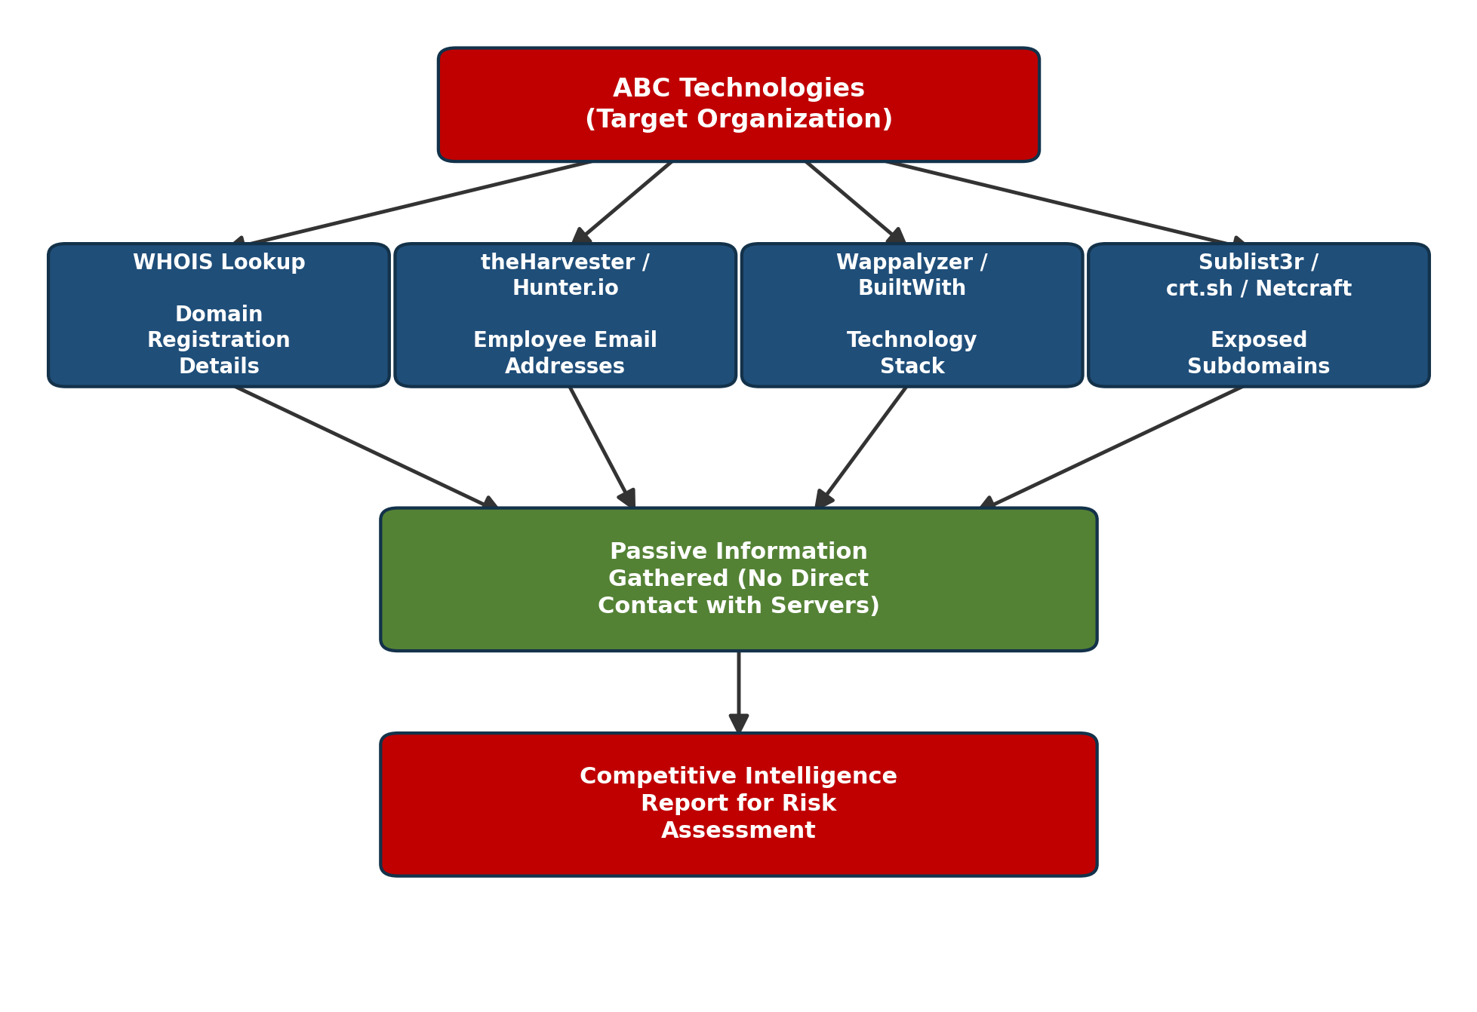
Fig. 1 — Passive footprinting workflow for ABC Technologies
Step 4: Conclusion — How This Builds Competitive Intelligence
By combining WHOIS, theHarvester, Wappalyzer and Sublist3r/crt.sh, the consultant assembles a complete external profile of ABC Technologies — ownership and infrastructure (WHOIS), human attack surface (emails), technical attack surface (tech stack) and network attack surface (subdomains) — entirely from public sources. This composite picture is exactly what competitive intelligence requires: it shows how the organisation is structured and equipped without ever sending a single packet directly to its production servers, keeping the assessment fully passive and legally safe.

Q2. DNS Zone Transfers
SCENARIO
During an authorized penetration test, a security analyst suspects that the target organization's DNS server is misconfigured and may allow unauthorized DNS zone transfers. Task: Apply the appropriate DNS command or tool to verify whether zone transfers are permitted. If the transfer succeeds, explain how the retrieved DNS records can be used to identify internal hosts, mail servers, and subdomains during reconnaissance.
Step 1: Identify the Authoritative Name Servers
Before attempting a transfer, the analyst must first discover which name servers are authoritative for the target domain.
- Command: host -t ns target.com (alternative: nslookup -type=ns target.com)
- This returns the list of authoritative DNS servers (e.g., ns1.target.com, ns2.target.com) that must be queried.
Step 2: Attempt an AXFR (Full Zone Transfer) Against Each Name Server
- Using dig: dig axfr @ns1.target.com target.com
- Using nslookup (interactive): nslookup → server ns1.target.com → ls -d target.com
- A properly configured server returns 'Transfer failed' / 'Connection refused'. A misconfigured server streams back the entire zone file.
Step 3: Interpret the Result
- If REFUSED: the server restricts zone transfers to authorised secondary DNS servers only — this is the secure, expected configuration.
- If SUCCESSFUL: the complete zone file is dumped to the analyst's console, exposing every DNS record configured for that domain — this is reported as a high-risk misconfiguration.
Step 4: Analyse the Retrieved Zone File
A successfully transferred zone file contains every resource record type configured for the domain. Each record type leaks specific reconnaissance value:
Record Type | Meaning | Reconnaissance Use
A / AAAA | Maps a hostname to an IPv4/IPv6 address | Reveals internal host names and their real IP addresses (web, DB, file servers)
MX | Identifies the mail server(s) for the domain | Pinpoints the mail server to target for phishing or email-based attacks
NS | Lists authoritative name servers | Maps the DNS infrastructure and secondary servers
CNAME | Alias of one hostname to another | Uncovers hidden/forgotten subdomains (e.g., old-vpn, test, staging)
TXT / SOA | Verification records, zone admin info | May leak SPF data, zone serial numbers and admin contact details
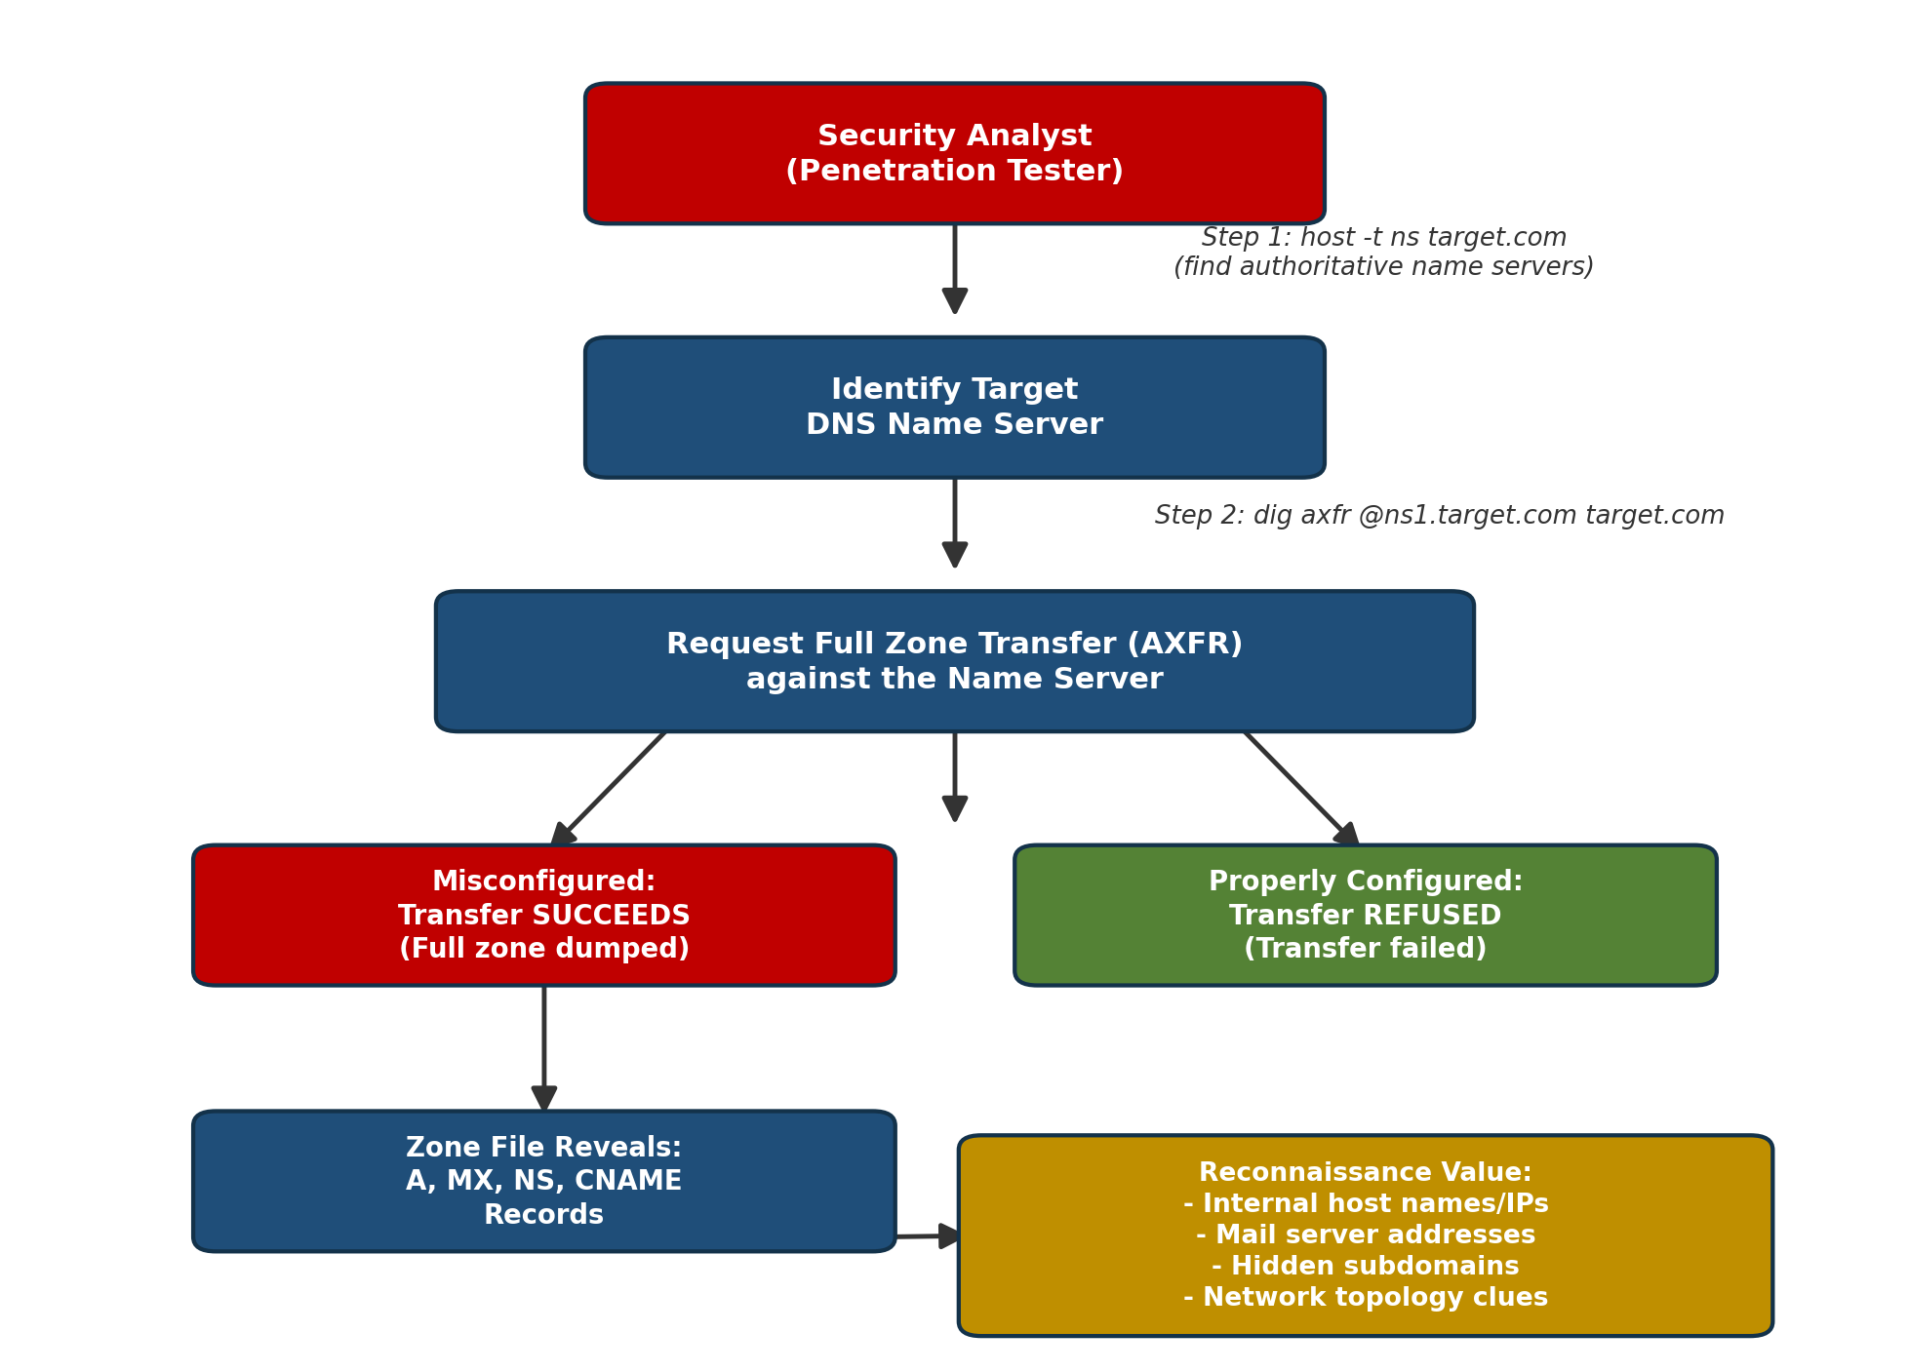
Fig. 2 — Step-by-step DNS zone transfer verification process
Step 5: Impact and Recommendation
A successful zone transfer hands the attacker (or, in this authorized test, the analyst) a ready-made map of the organisation's internal network — host names, internal IP ranges, mail servers and subdomains — without any brute-forcing. This dramatically accelerates later stages of an attack such as targeted phishing or direct exploitation of exposed internal hosts.
Recommendation to the organisation: restrict zone transfers (AXFR) to explicitly authorised secondary name-server IP addresses only, using the allow-transfer directive on BIND (or the equivalent ACL on the DNS platform in use), and consider enabling TSIG (Transaction Signatures) to cryptographically authenticate transfer requests.

Q3. Introduction to Social Engineering — Attacks and Countermeasures
SCENARIO
Employees of an organization receive an email claiming to be from the IT department, asking them to verify their login credentials through a provided link because of an urgent security update. Task: Identify the type of social engineering attack and apply suitable countermeasures that employees should follow before responding to the email. Explain how these actions help prevent credential theft.
Step 1: Identify the Type of Attack
This is a Phishing attack — specifically credential-harvesting phishing. The attacker impersonates a trusted internal entity (the IT department), creates a false sense of urgency ("urgent security update"), and directs the victim to a link designed to capture login credentials. Because it targets employees of one specific organisation using a pretext tailored to that workplace, it can further be classified as spear phishing.
Step 2: Recognise the Red Flags (Before Acting)
Red Flag | Why It Is Suspicious
Urgency / threat language | Pressures the victim into acting without thinking (classic social-engineering trigger)
Generic or mismatched sender address | 'IT Department' display name often hides a spoofed or external email address
Embedded link requesting credentials | Legitimate IT teams rarely ask users to 're-verify' passwords via email links
Spelling/grammar errors or odd formatting | Mass-sent phishing emails are often poorly localised or copied
Mismatched / shortened URL on hover | The visible link text differs from the actual destination URL
Step 3: Step-by-Step Countermeasures Employees Should Apply
- Verify the sender's actual email address (not just the display name) — check the full header for domain mismatches.
- Hover over the link (without clicking) to inspect the real destination URL before taking any action.
- Never enter credentials through an emailed link — instead, open a new browser tab and manually type the organisation's known URL, or use the official application directly.
- Watch for urgency, threats or unusual requests — treat any 'act now or lose access' message as a warning sign.
- Report the email immediately to the IT/Security team using the official reporting channel (e.g., 'Report Phishing' button) rather than replying to it.
- Ensure Multi-Factor Authentication (MFA) is enabled on the account so that a stolen password alone cannot be used to log in.
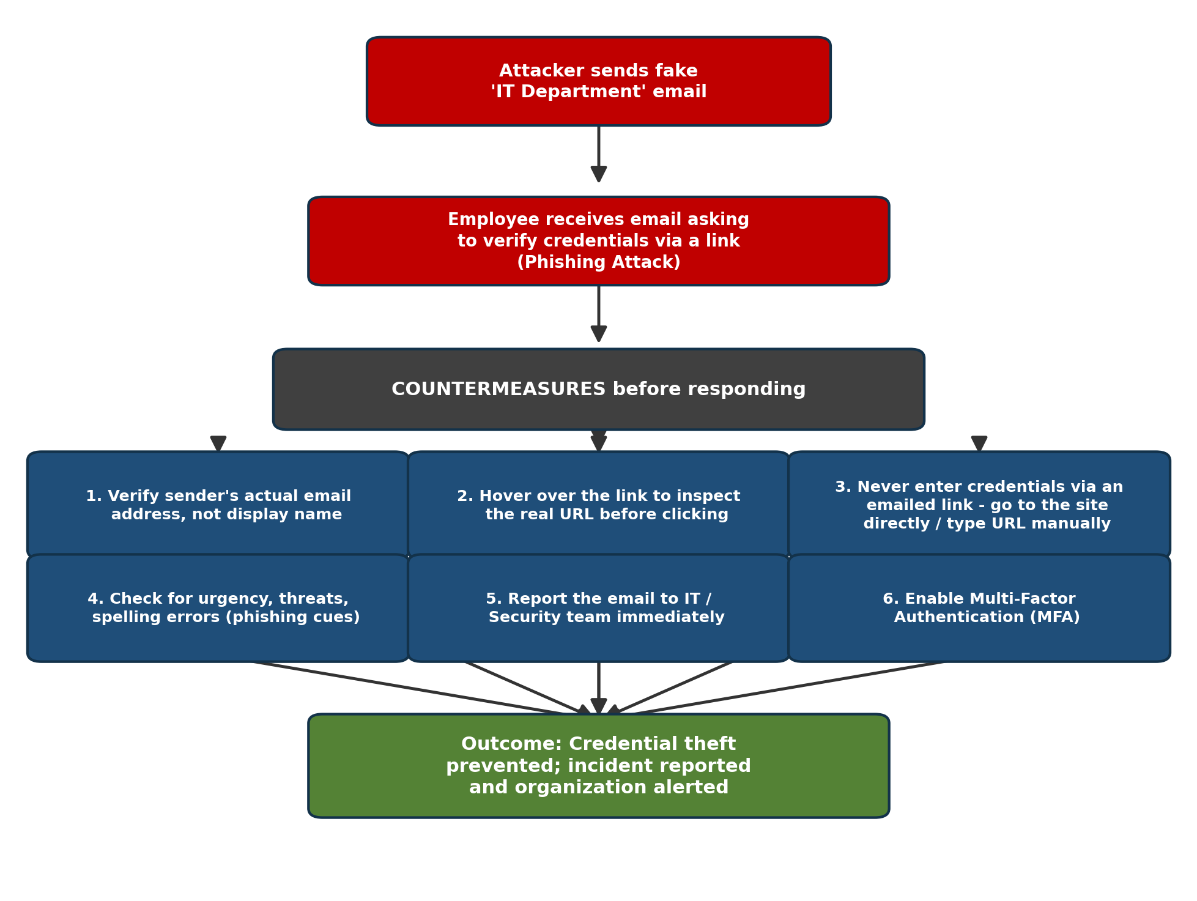
Fig. 3 — Phishing attack flow and employee countermeasure checklist
Step 4: How These Actions Prevent Credential Theft
Verifying the sender and inspecting the URL stops the attack at the reconnaissance stage — the employee never reaches the fake login page, so no credentials can be typed at all.
Typing the URL manually (instead of clicking the link) guarantees the employee only ever authenticates on the organisation's real, trusted login page, completely bypassing the attacker's cloned site.
Reporting the email allows the Security team to block the sender domain, warn other employees and take down the phishing infrastructure before more staff are targeted — containing the incident organisation-wide.
Enabling MFA ensures that even if credentials were mistakenly entered, the attacker still cannot log in without the second authentication factor (OTP, authenticator app, biometric, etc.), neutralising the value of the stolen password.
Step 5: Conclusion
This scenario is a textbook phishing (credential-harvesting) social-engineering attack. By training employees to pause, verify the sender, avoid clicking embedded links, report suspicious emails, and rely on MFA as a safety net, the organisation builds a human firewall that stops credential theft before it can succeed — complementing any technical email-filtering controls already in place.

